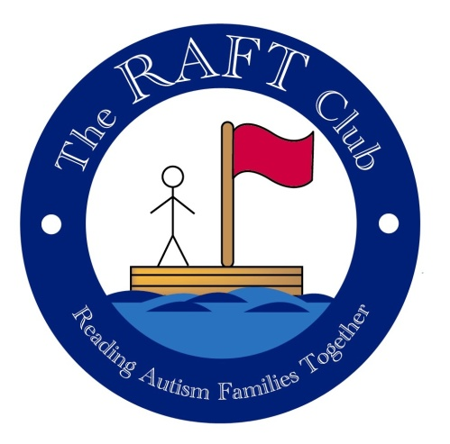
Physical Handling Policy

At RAFT we understand that some ASD children may demonstrate behaviour that is extremely difficult to handle, however we will always endeavour to manage inappropriate behaviour through reinforcement of rules, distraction, modifying the environment that the child is in or reducing sensory overload.
Physical punishment will never be used.
However, physical intervention may be used to prevent an accident or injury or damage if a child should have a violent outburst putting children or members of staff at risk.
One of our Play Workers is trained in Team Teach to safely restrain and calm down individuals in an appropriate and safe manner when deemed absolutely necessary in the RAFT setting.
The skills and techniques taught on a Team-Teach course are as a result of an on-going risk assessment in an effort to safeguard everyone involved in a violent incident where physical interventions are necessary.
Team-Teach techniques seek to avoid injury to the service user, but whilst some physical injury potential can be reduced there remains some risk, with potential for possible bruising or scratching that may occur accidentally, and these are not to be seen necessarily as a failure of professional technique, but a regrettable and infrequent side effect of ensuring that the service user remains safe.
Parents will be informed immediately if the Team-Teach technique has been employed. Equally if a child needs to be physically restrained it will be done usually with the parent present and consent given.
Parents and staff will work together to discuss ways that this could be avoided in the future.
This policy was adopted by RAFT at a meeting held on 18/11/15
Signed on behalf of RAFT by Michele Page (Chair)

